Michael Sindle

Module 2.2 Assignment
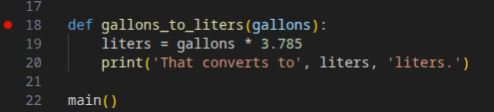

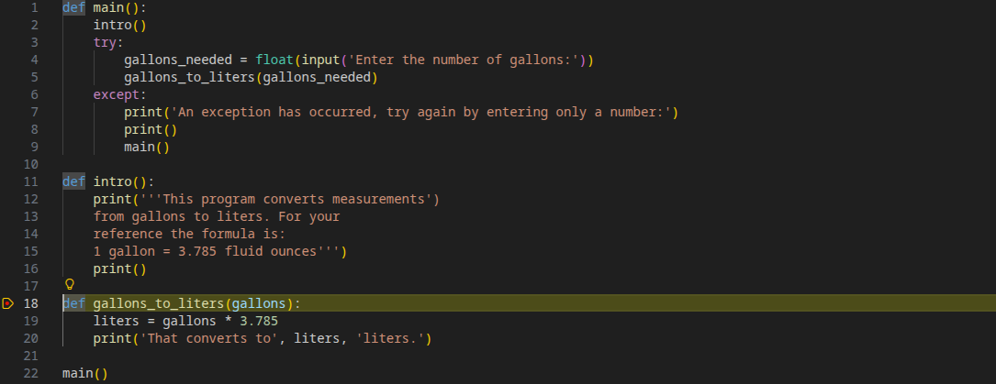

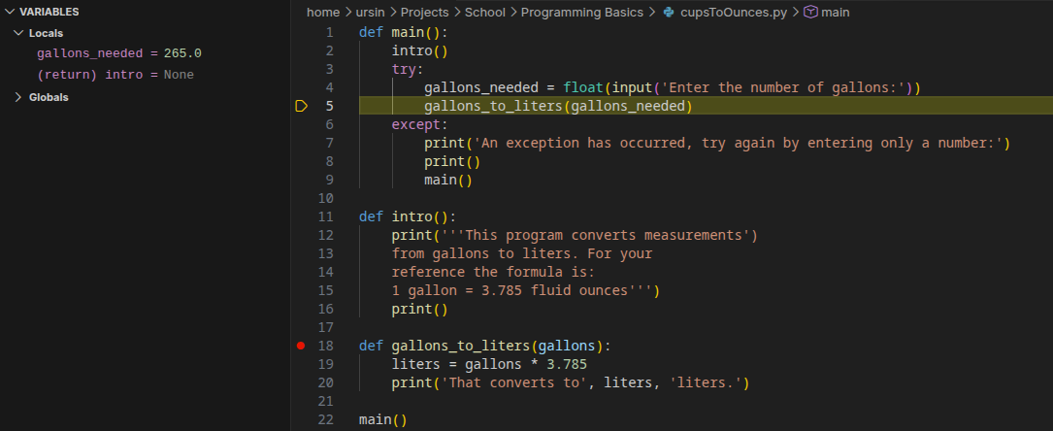
I steped through the program until I got to where gallons_needed gets defined and added the input the next line calls the function of gallons_to_liters but you can see the variables assigned in the top left.

